NAME: Ch. Rohith
REG NO:192525453
COURSE CODE: CSA1511
COURSE: Cloud computing and big data analysis

1.Cloud Computing Fundamentals. Include Defination, characteristics, benefits and limitations.

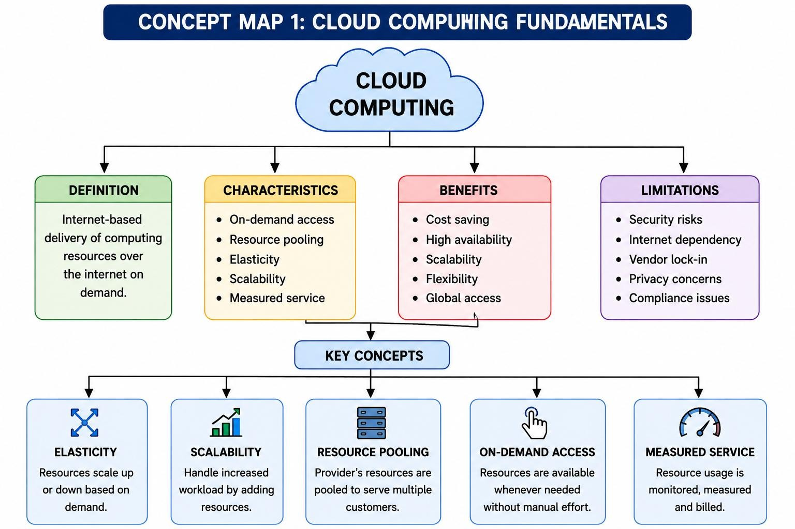

2. Evolution of Cloud Computing. Connect hardware evolution internet software evolution, distributed systems and service delivery.
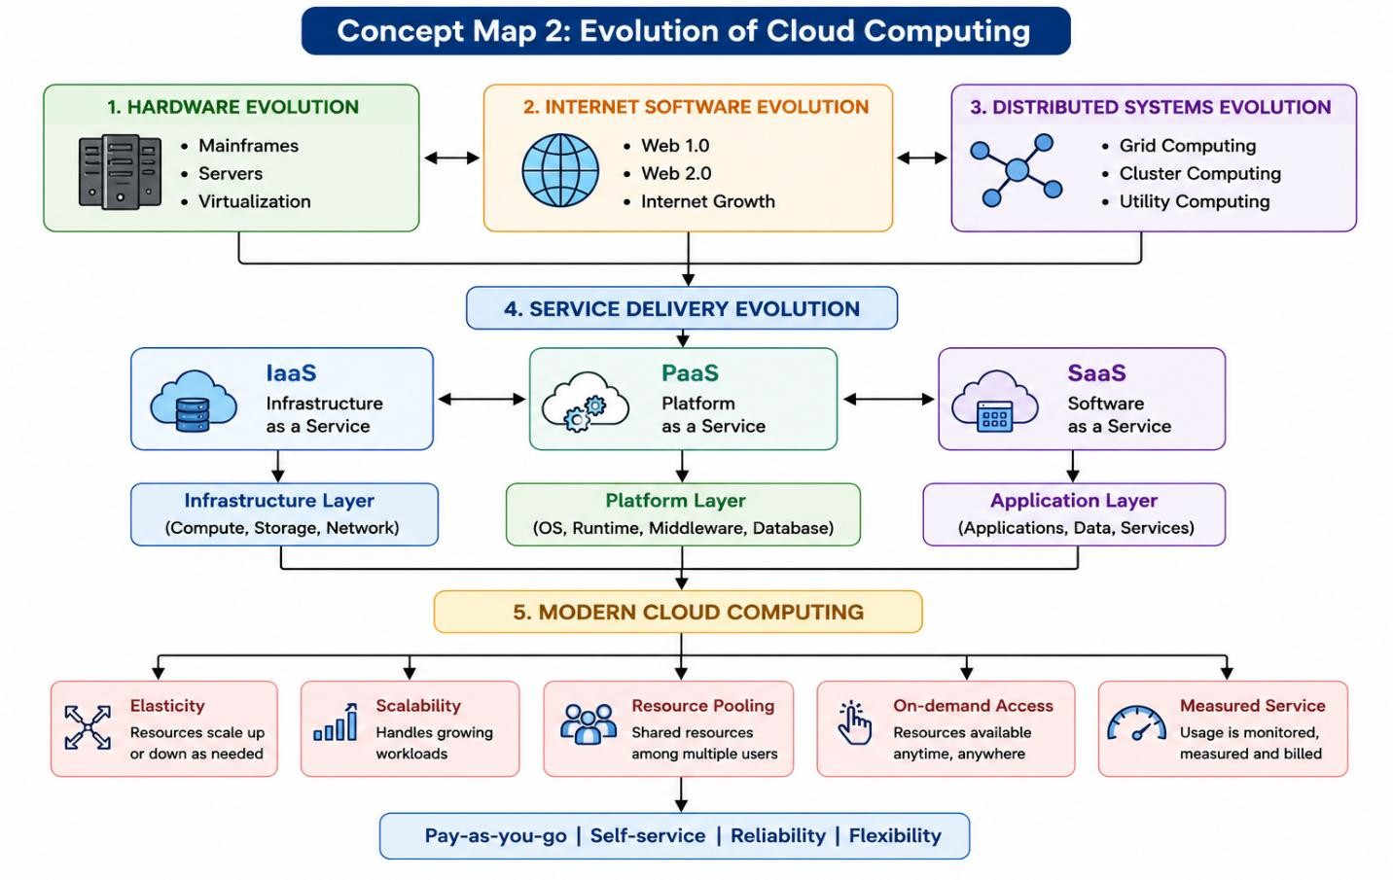

3.Service Models. Map Iaas, Paas, SaaS and XaaS with provider responsibilities and user responsibilities.

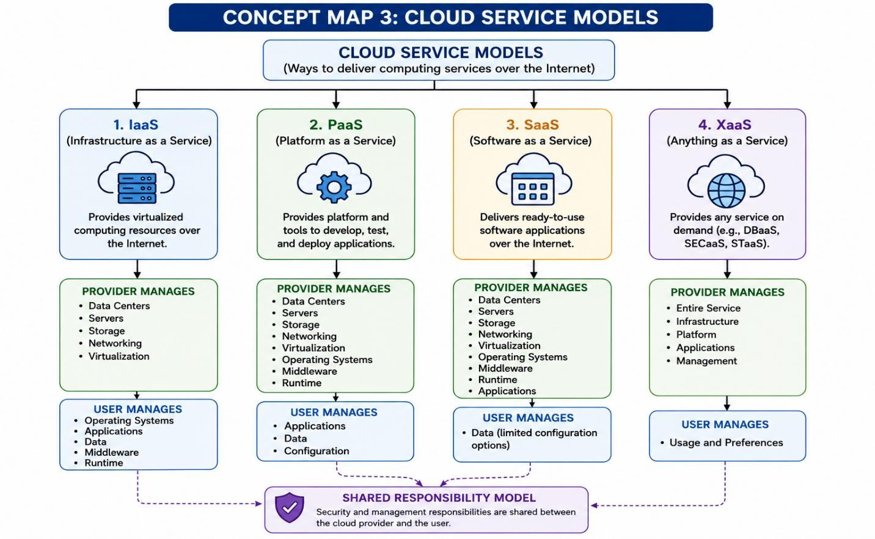
4.Virtualization and Web services as enablers of cloud. Show hoe these two concepts support cloud deployment and scalability.

